The Neustar Help Desk

Internal Customer Support Handbook—For Non-Neustar Issued EquNNe

Test 1

The **Neustar** Help Desk

Internal Customer Support Handbook—*Non-Neustar Issued Equipment*

Contents

Steps for Wireless Access 2

Zscaler Login 2

Connecting to Internal Sites and Resources 3

How to Login to SharePoint 3

Steps for Accessing Network Share Drives (G: Group & I: Public) 3

Printers 4

Email Access 6

Webmail 6

How to Configure Microsoft Outlook 6

IM / Chat Clients 7

Office Communicator – Software Client 7

Office Communicator – Web Client 7

Jabber Account Set-Up 7

Changing your network password 8

How to submit a Service Request 9

VPN – SSL VPN (Juniper): Web-Based Connection 11

How to Login 11

Quick Links 13

# Steps for Wireless Access

1. Plug in your computer with a network cable in order to access the network drive to get the wireless cert
2. Go to the Start menu, select Run, and type in \\stnetappb02.cis.neustar.com
3. When prompted for your user name, type in: **CIS\username** and your **password**
4. Navigate to **group** folder, then **Cert** folder, and install the certificate

\\stnetappb02.cis.neustar.com\group\Certs

1. You can then connect to the Fud1aow network using your credentials

# Zscaler Login

1. Zscaler is our web content filter: it prevents end users from going to malicious websites. It is a one-time login, unless you clear your browser history and cache.
2. Login with your Neustar email address ([john.doe@neustar.biz](mailto:john.doe@neustar.biz)) and password.

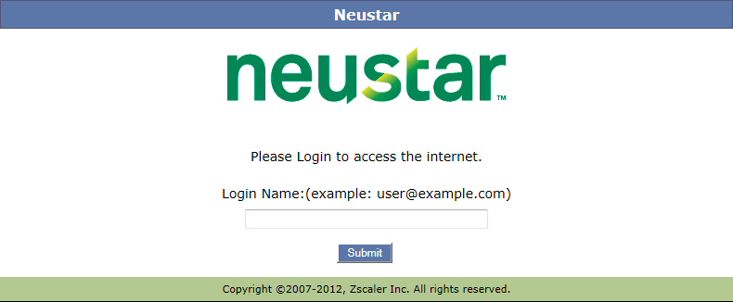

# Connecting to Internal Sites and Resources

## How to Login to SharePoint

1. Access SharePoint by pointing your browser to: <https://neushare.cis.neustar.com>
2. Enter your Username (ex. jdoe)
3. In the Password field, enter your Network Password, click ‘Continue’

*Note: This is the Network password was provided by the Help Desk*

1. Once logged into SharePoint, users can only access information after additional approval is granted by site administrators. Please work with your responsible/hiring manager to gain access to specific team sites/materials

## Steps for Accessing Network Share Drives (G: Group & I: Public)

**For Windows:**

1. Go to Start menu, select Run, and type in:

\\stnetappb02.cis.neustar.com\group (for G: Drive)

\\stnetappb02.cis.neustar.com\public (for I: Drive)

1. When prompted for user name type in: **CIS\username** and **network password**

**For MAC:**

To connect to a network drive (such as the Group drive, or your personal storage space), use keyboard shortcut command+k or from the Finder menu, select Go, and then select “Connect to Server” from the drop down menu. The following window will appear:

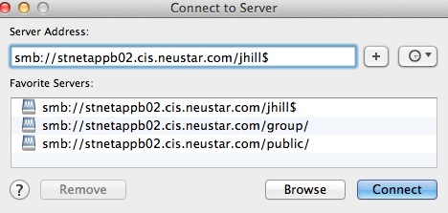

You will use smb:// followed by the path to get to the network drive that you wish to connect to. Examples above are the G: drive (typically where groups store/share data), as well as the path for connecting to a user’s own personal storage space (U: drive).

At this point you’ll be able to access the folder(s) to which you have been granted permissions. Speak with your manager in regards to which folders you need to access.

*Note: You may receive links which may not work in your browser, such as* [*http://neushare/Pages/NeuShare.com*](http://neushare/Pages/NeuShare.com)*. Depending on how your computer is set up, you may need to enter the fully qualified domain name (FQDN) in order to reach some internal sites and resources. To do this, add* ***cis.neustar.com*** *to the URL of the site (ex.* [*https://neushare.****cis.neustar.com***](https://neushare.cis.neustar.com)*)*

## Printers

**For Windows:**

To connect to a Neustar printer, go to the Start Menu, select Run, and type in: \\stntps1.cis.neustar.com

Double-click one or more printer(s) to load the drivers and map the printer(s) to your laptop.

**For MAC:**

To map to a network printer you will need to know the printer name and the IP address of the printer then open up System Preferences from the dock, and under the Hardware section, choose Print & Scan

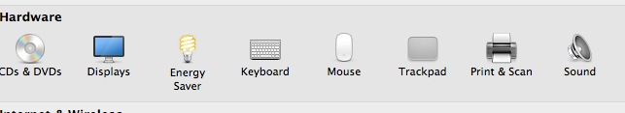

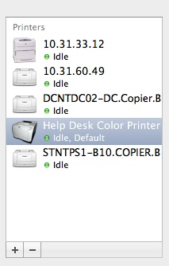

Click on the + button at the bottom of the left window pane to add a printer.

On the next window, you will need to click the IP tab and enter the IP address of the printer you are adding. Typically, the Line Printer Daemon – LPD protocol (default) and Generic PostScript Printer (default) settings will work. When you enter the IP address in the Address line, it will replicate also in the bottom portion on the Name field – you can edit this to the actual name of the printer, so it displays properly in the printer window on the machine screen.

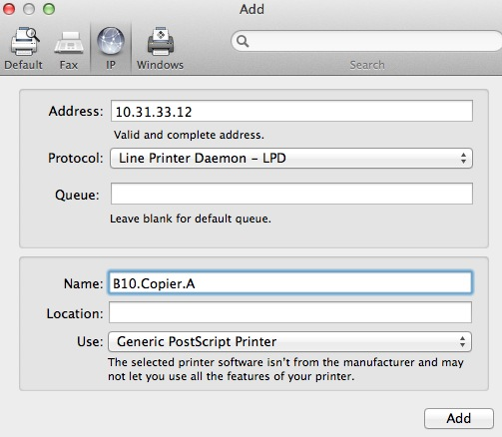

On some printers, such as the Canon that is located in RT3 and the DC office, specific software drivers from the manufacturer are needed, and you can get these by going to the manufacturer website and searching for the printer model (the drivers are specific to which version of OS X you are using).

## Email Access

### Webmail

If you are in a Neustar office or remotely connected via the VPN, connect to mail by going to: <https://eastcoastcas.cis.neustar.com/owa>

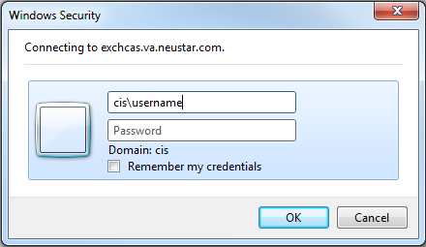

### How to Configure Microsoft Outlook

1. Install the Exchange certificate from the following location: \\stnetappb02.cis.neustar.com\group\- Help Desk\Cert
2. Go to the Control Panel, Select Mail, choose Email Accounts, then select New:

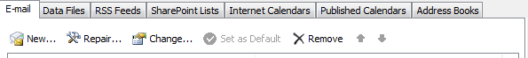

1. Choose manually configure:

**C:\Users\jwharam\Desktop\manually.PNG**

1. Select Microsoft Exchange:

**C:\Users\jwharam\Desktop\exchange.PNG**

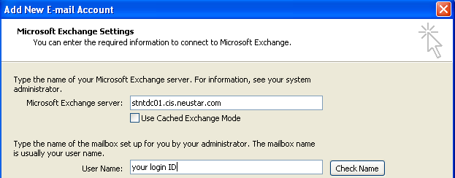

For the Exchange server, type in: **stntdc01.cis.neustar.com**

For User Name, enter your network username and select **Check Name**

**IM / Chat Clients**

### Office Communicator – Software Client

1. Enter your Neustar email address and password.
2. Under the **Advanced Communication Settings**, enter the following information:

Internal server name: stntocs01.cis.neustar.com

External server name: exchcas.va.neustar.com

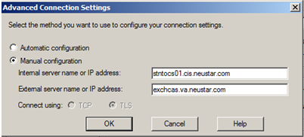

### Office Communicator – Web Client

If you are in a Neustar office or remotely connected via the VPN, connect to the Web Communicator by going to: <https://cwa.cis.neustar.com>

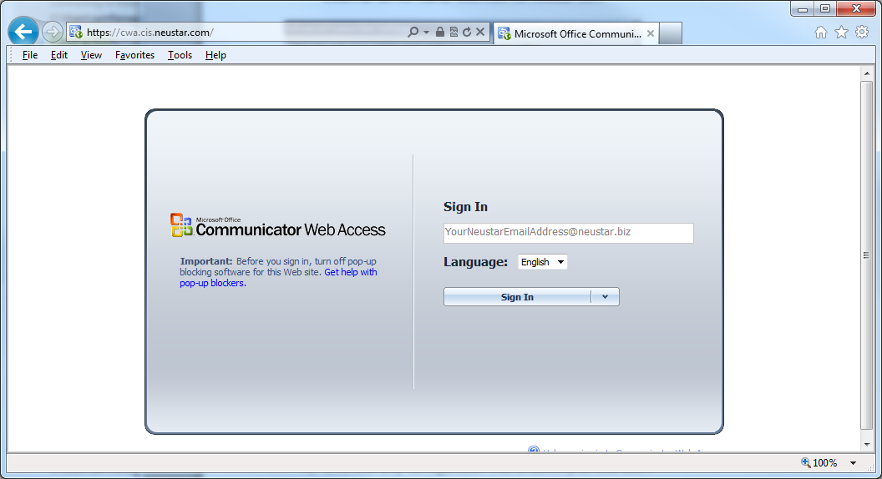

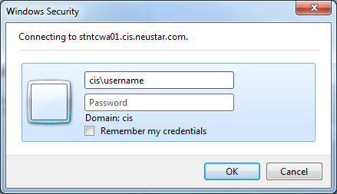

### Jabber Account Set-Up

You will need an XMPP-compliant client—such as Jabber, Pidgin, or Trillian—and your Neustar username and password.

1. Under the client configuration, add the domain as jabber.neustar.biz.
2. Leave the Resource field blank, unless the client auto-populates it, like Adium on Mac).
3. Under Advanced, select **enable ssl** or **enable encryption**.
4. Uncheck any configuration that enables plaintext auth.

**Changing your Network Password**

Network Credentials “Windows Credentials, Logon Credentials, Logon ID & Password”

Your Network password allows access to many of Neustar’s Network resources including, but not limited to: Computer login, PeopleSoft, Neuconnect, Service-Now, SalesForce and Jabber.

Remote Access Credentials

These credentials allow access to many of Neustar’s Network resources including, but not limited to: Juniper VPN, Cisco VPN, OWA Web Mail

Your passwords should remain private and should not be written down. In the event that your password is compromised (or you suspect it was compromised), it is important that you change your password immediately, as well as notify the Neustar Help Desk immediately.

Network credentials:

Your credentials are required to be changed every 90 days. A notification will be sent 14 days before the expiration date via Email. Password Requirements: *It must be a minimum of 8 characters and contain 3 of the following: Uppercase, Lowercase, Number and/or special symbol.*

Changing your CIS password is a simple process that can be done while on the Neustar network. Simply go to the following URL and log on using your Neustar username and password:

Self Service Portal: <https://stnthdtools01.cis.neustar.com:9251/checkURL.do>

Once you have logged in, click on the **Change Password** tab, enter your current password, and create a new one.

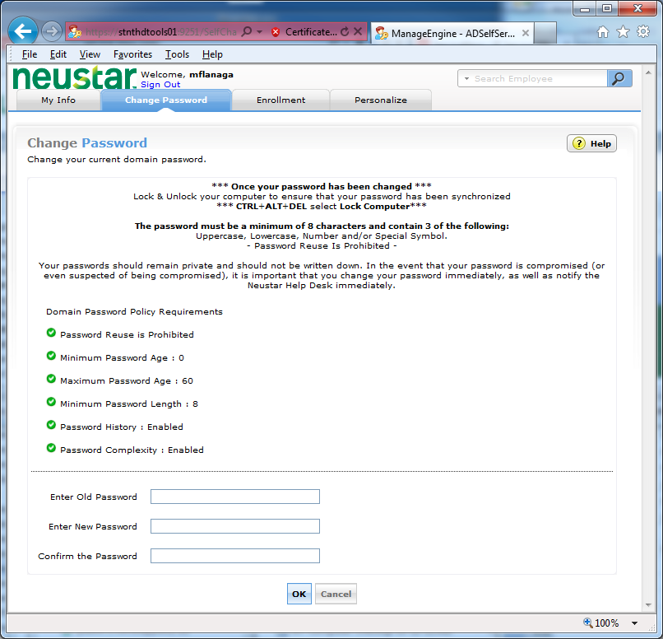

**Please be sure to follow the additional instructions after you have changed your password to ensure that your password is synchronized across network applications.**

## How to submit a Service Request

Employee Self Service (ESS): <https://neustar.service-now.com/>. This site is accessible on and off the Neustar network. To login you will use your network username and password. Please submit all trouble tickets and requests within the ESSportal.

On the **ESS Homepage**, go to **IT Services for Users** and select **Internal HelpDesk** to create your ticket.

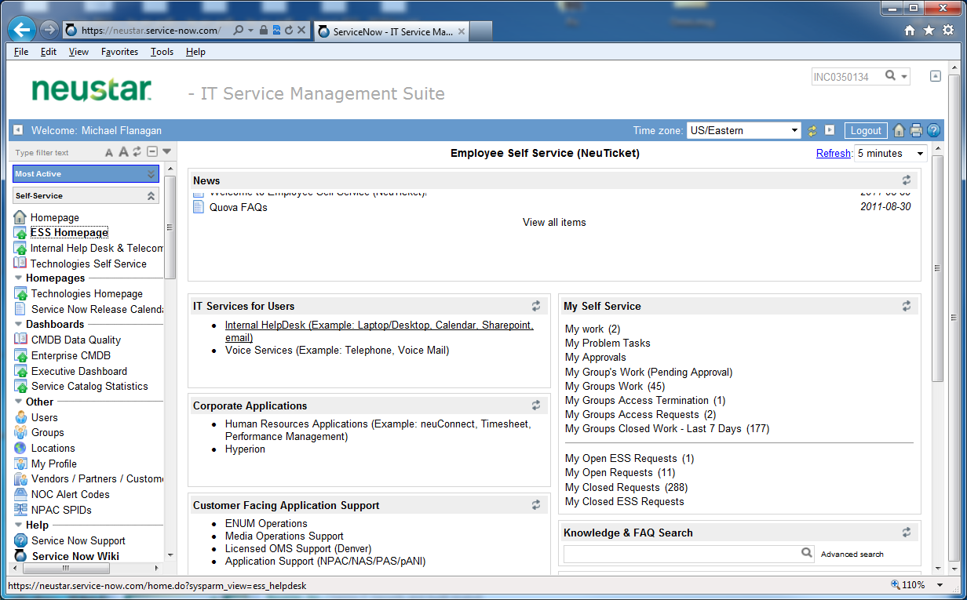

Select Internal HelpDesk

On the following screen, select a category to create a ticket. You can also view your open requests under **My Open Service Requests**. Once you have created the ticket, you will receive an e-mail message with your ticket number.  To update the ticket, reply directly to that e-mail or click on the link provided.

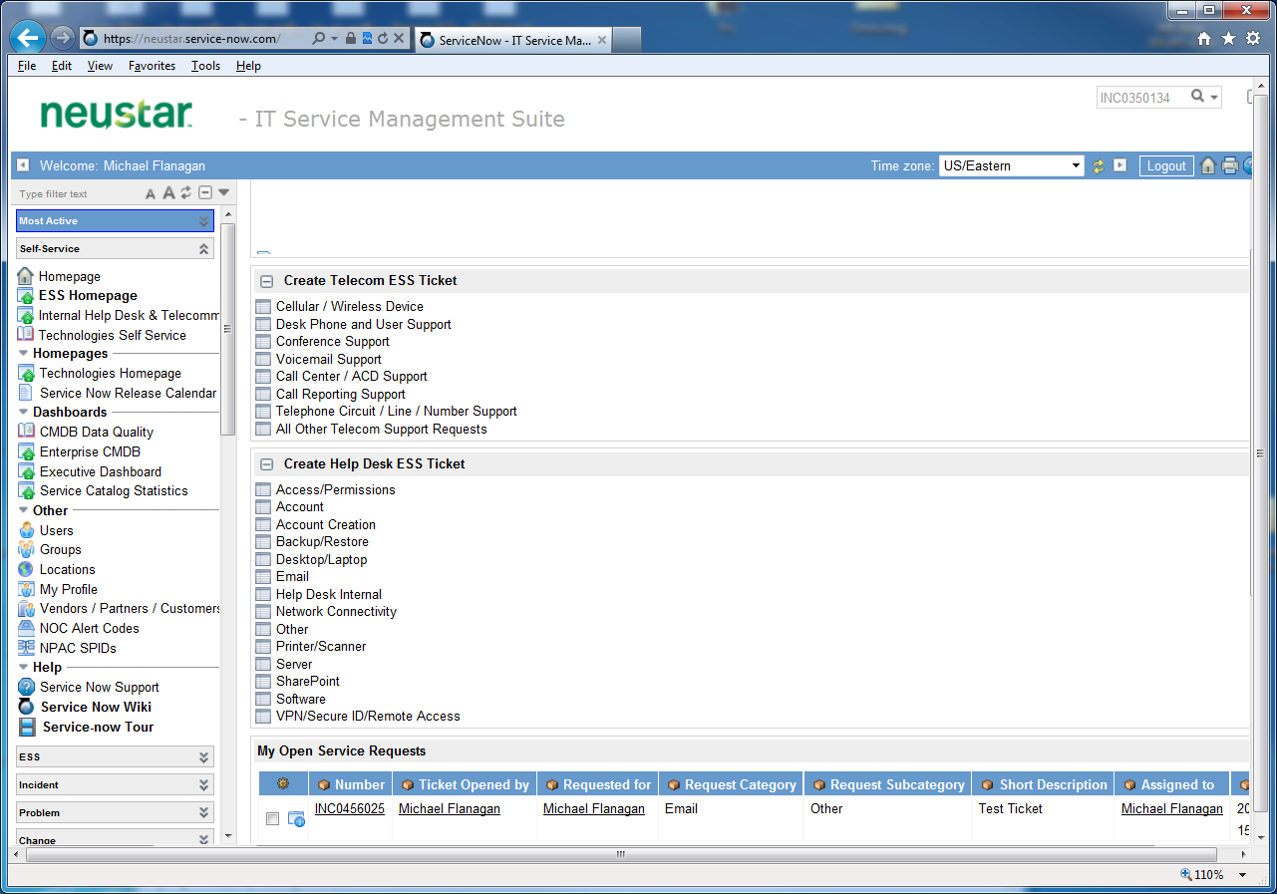

**Remote Access**

Neustar offers remote network access to employees on the go. This section will cover the types of remote access Neustar offers you.

Access can be obtained from outside the Neustar network by Broadband/High-speed connections. All remote connections require the use of your Symantec VIP Access soft token.

|  |  |
| --- | --- |
| Connection Type | Description |
| **Broadband/High-speed** |  |
| Juniper VPN | Application installed connection |
| Juniper Web Access Portal | Web based connection |
| OWA Web Mail | Outlook Web Application |

Connect to Juniper VPN with your Neustar approved computer and it will allow your computer/device to have the same network access as if you were onsite.

Juniper Web Access Portal provides two different connection options: one for your Neustar-issued and Neustar approved computers and devices. This will allow your computer/device to have the same network access as if you were onsite. The other for **non**-Neustar issued and **unapproved** computers and devices such as home and hotel guest computers.

OWA Web Mail can be used from any computer with Internet access. This will allow you to use the basic functions of Outlook to Send/Receive and manage your mail.

Symantec VIP Access Token

**To connect to the VPN you will need to install the Symantec VIP Access token.**

***Computer Install***- <https://idprotect.verisign.com/desktop>

***Mobile device Install****– from your mobile device web browser:* <http://m.verisign.com>

Please Email the Help Desk a screenshot of your credential ID from your VIP Access token.

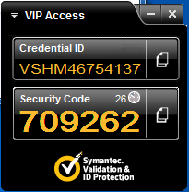

## VPN – SSL VPN (Juniper): Web-Based Connection

When you are not at a physical Neustar facility, connect to the VPN in order access Neustar’s network resources.

### How to Login

Juniper Web Client

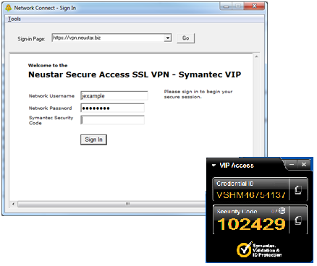

Logging in with your software token

Since Neustar incorporates state-of-the-art two factor authentication, use your Symantec VIP software token

1. Open a Web Browser and go to <https://vpn.neustar.biz>
2. Enter your Network Username (e.g. **jexample**)
3. Enter your Network Password
4. Enter your Security Code from your Computer or Mobile Access Symantec VIP software token

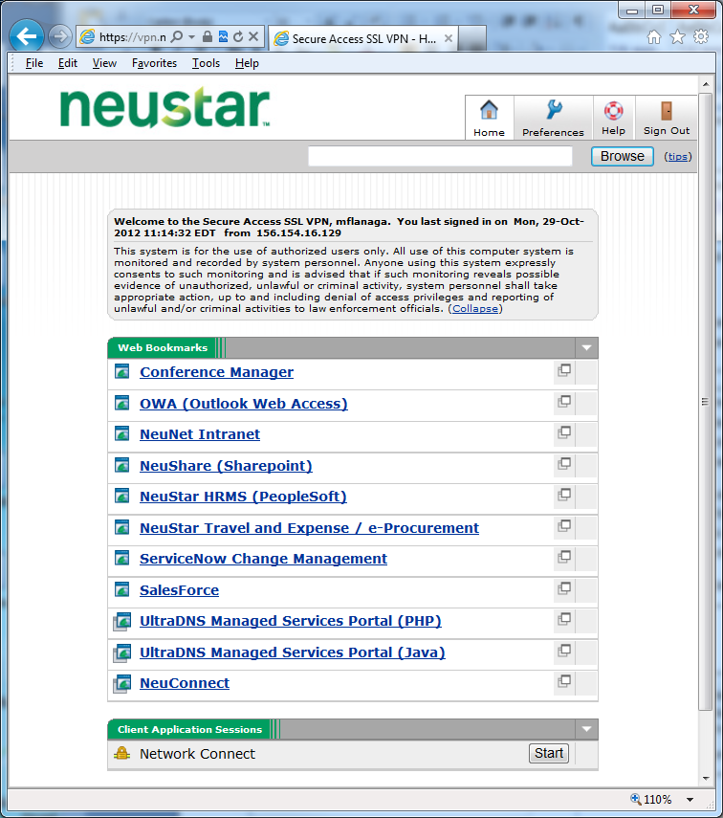

Once logged into the Juniper site there are 2 sections:

**Web Bookmarks** & **Client Application Session**

**Web Bookmarks –** Allows access from a non-Neustar-issued or non-approved computer to the following links.

**Client Application Session –**Allows a VPN Tunnel from your Neustar-issued and Neustar approved computers and devices to the Neustar CIS domain. To establish a connection, select **Start** and follow the onscreen instructions.

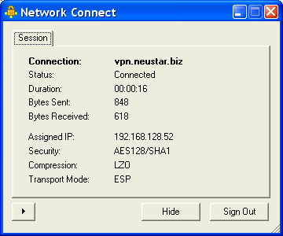

To sign out from the ***Client Application Session***

Select ***Sign Out***

1. In order to fully establish the VPN network connection, click on the ‘Start’ button adjacent to “Network Connect” under Client Application Sessions.



*Note: If the login is not successfully completed and your computer freezes, please contact your system administrator. Your computer settings may need to be adjusted to allow Juniper software to run correctly*

## Quick Links

Webmail/Web email (While on the Network Or VPN) : <https://exchcas.va.neustar.com/OWA>

Office Communicator – Web (While on the Network Or VPN) : <https://cwa.cis.neustar.com>

Sharepoint/Neushare: <http://neushare.cis.neustar.com>

G: Drive/Network Drive/Group Drive: \\stnetappb02.cis.neustar.com\group

I: Drive/Public Drive: \\stnetappb02.cis.neustar.com\public

VPN/Remote Access: <https://vpn.neustar.biz/contractor>

Printers: \\stntps1.cis.neustar.com

ServiceNow/Ticketing System: <https://neustar.service-now.com/>

Self Service Portal: <https://stnthdtools01.cis.neustar.com:9251/checkURL.do>